Nepal College of Information Technology
Assessment
Fall 2009
Program: IT-VII Time: 3 hrs
Semester: Fall FM: 100
Subject: Telecommunication PM: 50
Attempt ALL the questions.
1. a). What are the advantages of automatic switching over manual? Enlist the factors on which proper functioning of uni-selectors depends and the parts of figure shown below with comparison between selector hunter base access and line finder based access.
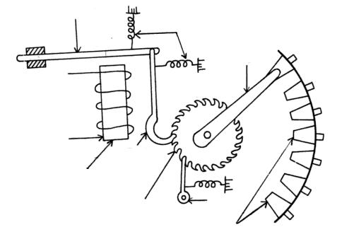
b). Discuss FRESNEL ZONES and fading vs. diversity. Elaborate different diversity techniques with respective diagrams.
2 a) What is PCM? An Erlang-B loss system with n = 4 channels, arrival rate = 2 calls per time unit, and departure rate = 2 departures per time unit. Evaluate time, traffic, call congestion.
b). Define NGN and convergence of media? How MPLS, ISA and DS enhance the system performance of telephony? Discuss comparatively.
3 a). How telephone traffic can be modeled? Discuss the following terms on the basis of traffic engineering with derivation of Erlang B formula.
a). GOS c). BHCR
b). BHCA d). CCR
b). Define broad band ISDN. What are B, D and H channels? Discuss LAPD protocol for D channel.
4 a). Compare and contrast in channel vs. common channel signaling. Discuss SS7 and compare it with OSI.
b). Define echo, singing and jitter? Discuss the basic phenomenon of crosstalk with its types.
5 a). What is little’s theorem? Evaluate traffic carried, traffic offered,GOS,CCR for an exchange with 2000 calls of which 10 gets drop in an observation period of 30 mins.
b). Discuss principle of operation of TDMA, CDMA, FDMA and SDMA. Explain PDH and SDH with basic frame structure of SONET.
6 a). What does SQNR= 1.7+ 6.02n means? Why digital is superior to analog system? Elaborate sampling operation for v (t) =20 sin880t if quantization noise of 13db is the limit for communication.
b). Explain PSTN hierarchy. Elaborate the difference between throughputs of aloha and slotted aloha and evaluate the number of terminals that can be handled by both for capacity of 2mbps with 2KB of data originating at 1min at each.
7. Write short notes on:
i. T1 vs. E1
ii. Queuing theory
iii. QOS

